BÀI TẬP TUẦN 10
Tên: Hà Minh Tiến
MSSV: 1250080194
Lớp: CNTT4

SOURCE CODE:
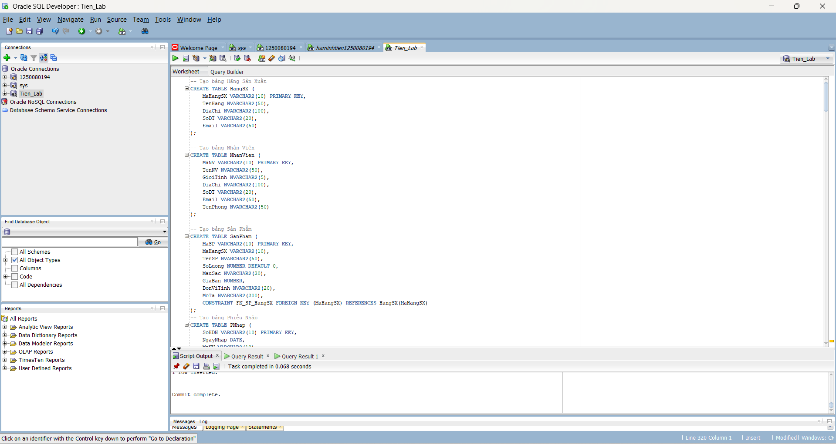
-- Tạo bảng Hãng Sản Xuất
CREATE TABLE HangSX (
MaHangSX VARCHAR2(10) PRIMARY KEY,
TenHang NVARCHAR2(50),
DiaChi NVARCHAR2(100),
SoDT VARCHAR2(20),
Email VARCHAR2(50)
);

-- Tạo bảng Nhân Viên
CREATE TABLE NhanVien (
MaNV VARCHAR2(10) PRIMARY KEY,
TenNV NVARCHAR2(50),
GioiTinh NVARCHAR2(5),
DiaChi NVARCHAR2(100),
SoDT VARCHAR2(20),
Email VARCHAR2(50),
TenPhong NVARCHAR2(50)
);

-- Tạo bảng Sản Phẩm
CREATE TABLE SanPham (
MaSP VARCHAR2(10) PRIMARY KEY,
MaHangSX VARCHAR2(10),
TenSP NVARCHAR2(50),
SoLuong NUMBER DEFAULT 0,
MauSac NVARCHAR2(20),
GiaBan NUMBER,
DonViTinh NVARCHAR2(20),
MoTa NVARCHAR2(200),
CONSTRAINT FK_SP_HangSX FOREIGN KEY (MaHangSX) REFERENCES HangSX(MaHangSX)
);
-- Tạo bảng Phiếu Nhập
CREATE TABLE PNhap (
SoHDN VARCHAR2(10) PRIMARY KEY,
NgayNhap DATE,
MaNV VARCHAR2(10),
CONSTRAINT FK_PNhap_NV FOREIGN KEY (MaNV) REFERENCES NhanVien(MaNV)
);

-- Tạo bảng chi tiết Nhập
CREATE TABLE Nhap (
SoHDN VARCHAR2(10),
MaSP VARCHAR2(10),
SoLuongN NUMBER,
DonGiaN NUMBER,
CONSTRAINT PK_Nhap PRIMARY KEY (SoHDN, MaSP), -- Khóa chính kết hợp [cite: 24]
CONSTRAINT FK_Nhap_PNhap FOREIGN KEY (SoHDN) REFERENCES PNhap(SoHDN),
CONSTRAINT FK_Nhap_SP FOREIGN KEY (MaSP) REFERENCES SanPham(MaSP)
);

-- Tạo bảng Phiếu Xuất
CREATE TABLE PXuat (
SoHDX VARCHAR2(10) PRIMARY KEY,
NgayXuat DATE,
MaNV VARCHAR2(10),
CONSTRAINT FK_PXuat_NV FOREIGN KEY (MaNV) REFERENCES NhanVien(MaNV)
);

-- Tạo bảng chi tiết Xuất
CREATE TABLE Xuat (
SoHDX VARCHAR2(10),
MaSP VARCHAR2(10),
SoLuongX NUMBER,
CONSTRAINT PK_Xuat PRIMARY KEY (SoHDX, MaSP), -- Khóa chính kết hợp [cite: 25]
CONSTRAINT FK_Xuat_PXuat FOREIGN KEY (SoHDX) REFERENCES PXuat(SoHDX),
CONSTRAINT FK_Xuat_SP FOREIGN KEY (MaSP) REFERENCES SanPham(MaSP)
);
--Phieuhoctap1
--INSERT bảng NHAP – trg_Nhap
CREATE OR REPLACE TRIGGER trg_Nhap
BEFORE INSERT ON Nhap
FOR EACH ROW
DECLARE
v_dem NUMBER := 0;
BEGIN
SELECT COUNT(*) INTO v_dem FROM SanPham WHERE MaSP = :NEW.MaSP;
IF v_dem = 0 THEN
RAISE_APPLICATION_ERROR(-20001, 'Ma san pham khong ton tai'); -- [cite: 5, 16]
END IF;
IF :NEW.SoLuongN <= 0 OR :NEW.DonGiaN <= 0 THEN
RAISE_APPLICATION_ERROR(-20002, 'SoLuong va DonGia phai > 0'); --
END IF;
UPDATE SanPham SET SoLuong = SoLuong + :NEW.SoLuongN WHERE MaSP = :NEW.MaSP;
END;
SELECT * FROM Nhap;
INSERT INTO Nhap (SoHDN, MaSP, SoLuongN, DonGiaN) VALUES ('N01', 'SP01', 5, 12000000);
SELECT MaSP, SoLuong FROM SanPham WHERE MaSP = 'SP01';
--INSERT bảng XUAT – trg_xuat
CREATE OR REPLACE TRIGGER trg_xuat
BEFORE INSERT ON Xuat
FOR EACH ROW
DECLARE
v_dem NUMBER := 0;
v_soluong NUMBER := 0;
BEGIN
SELECT COUNT(*) INTO v_dem FROM SanPham WHERE MaSP = :NEW.MaSP;
IF v_dem = 0 THEN
RAISE_APPLICATION_ERROR(-20001, 'Ma san pham khong ton tai');
END IF;
SELECT SoLuong INTO v_soluong FROM SanPham WHERE MaSP = :NEW.MaSP;
IF :NEW.SoLuongX > v_soluong THEN
RAISE_APPLICATION_ERROR(-20003, 'So luong xuat vuot qua ton kho');
END IF;
UPDATE SanPham SET SoLuong = SoLuong - :NEW.SoLuongX WHERE MaSP = :NEW.MaSP;
END;
SELECT * FROM Xuat;
INSERT INTO Xuat (SoHDX, MaSP, SoLuongX) VALUES ('X01', 'SP01', 3);
SELECT MaSP, SoLuong FROM SanPham WHERE MaSP = 'SP01';
--DELETE bảng XUAT – trg_XoaXuat
CREATE OR REPLACE TRIGGER trg_XoaXuat
AFTER DELETE ON Xuat
FOR EACH ROW
BEGIN
UPDATE SanPham SET SoLuong = SoLuong + :OLD.SoLuongX WHERE MaSP = :OLD.MaSP;
END;
SELECT * FROM Xuat;
DELETE FROM Xuat WHERE SoHDX = 'X01' AND MaSP = 'SP01';
SELECT MaSP, SoLuong FROM SanPham WHERE MaSP = 'SP01';
--Tạo Package lưu biến đếm chung
CREATE OR REPLACE PACKAGE pkg_state AS
g_row_count NUMBER := 0;
END pkg_state;
--Phieuhoctap 2
--Trigger UPDATE bảng XUAT – trg_CapNhatXuat
CREATE OR REPLACE TRIGGER trg_CapNhatXuat
FOR UPDATE ON Xuat
COMPOUND TRIGGER
BEFORE STATEMENT IS
BEGIN
pkg_state.g_row_count := 0;
END BEFORE STATEMENT;
BEFORE EACH ROW IS
v_soluong NUMBER := 0;
BEGIN
pkg_state.g_row_count := pkg_state.g_row_count + 1;
IF pkg_state.g_row_count > 1 THEN
RAISE_APPLICATION_ERROR(-20001, 'Chi duoc cap nhat 1 ban ghi');
END IF;
IF :NEW.SoLuongX <> :OLD.SoLuongX THEN
SELECT SoLuong INTO v_soluong FROM SanPham WHERE MaSP = :NEW.MaSP;
IF (:NEW.SoLuongX - :OLD.SoLuongX) > v_soluong THEN
RAISE_APPLICATION_ERROR(-20004, 'Khong du hang de xuat');
END IF;
UPDATE SanPham SET SoLuong = SoLuong - (:NEW.SoLuongX - :OLD.SoLuongX)
WHERE MaSP = :NEW.MaSP;
END IF;
END BEFORE EACH ROW;
END trg_CapNhatXuat;
SELECT * FROM XUAT;
INSERT INTO Xuat (SoHDX, MaSP, SoLuongX) VALUES ('X01', 'SP01', 3);
UPDATE Xuat SET SoLuongX = 5 WHERE SoHDX = 'X01' AND MaSP = 'SP01';
SELECT MaSP, SoLuong FROM SanPham WHERE MaSP = 'SP01';
--Trigger UPDATE bảng NHAP – trg_CapNhatNhap
CREATE OR REPLACE TRIGGER trg_CapNhatNhap
FOR UPDATE ON Nhap
COMPOUND TRIGGER
BEFORE STATEMENT IS
BEGIN
pkg_state.g_row_count := 0;
END BEFORE STATEMENT;
BEFORE EACH ROW IS
BEGIN
pkg_state.g_row_count := pkg_state.g_row_count + 1;
IF pkg_state.g_row_count > 1 THEN
RAISE_APPLICATION_ERROR(-20001, 'Chi duoc cap nhat 1 ban ghi');
END IF;
IF :NEW.SoLuongN <> :OLD.SoLuongN THEN
UPDATE SanPham SET SoLuong = SoLuong + (:NEW.SoLuongN - :OLD.SoLuongN)
WHERE MaSP = :NEW.MaSP;
END IF;
END BEFORE EACH ROW;
END trg_CapNhatNhap;
SELECT * FROM NHAP;
UPDATE Nhap SET SoLuongN = 10 WHERE SoHDN = 'N01' AND MaSP = 'SP01';
SELECT MaSP, SoLuong FROM SanPham WHERE MaSP = 'SP01';
--Trigger DELETE bảng NHAP – trg_XoaNhap
CREATE OR REPLACE TRIGGER trg_XoaNhap
AFTER DELETE ON Nhap
FOR EACH ROW
BEGIN
UPDATE SanPham SET SoLuong = SoLuong - :OLD.SoLuongN WHERE MaSP = :OLD.MaSP;
END;
SELECT MaSP, TenSP, SoLuong FROM SanPham WHERE MaSP = 'SP01';
DELETE FROM Nhap WHERE SoHDN = 'N01' AND MaSP = 'SP01';
--phieuhoctap 3
-- Tạo bảng Phong
CREATE TABLE Phong (
MaPhong VARCHAR2(10) PRIMARY KEY,
LoaiPhong NVARCHAR2(50),
TrangThai VARCHAR2(20),
GiaTheoGio NUMBER,
GiaTheoNgay NUMBER,
SoNguoiToiDa NUMBER
);

-- Tạo bảng KhachHang
CREATE TABLE KhachHang (
MaKH VARCHAR2(10) PRIMARY KEY,
HoTen NVARCHAR2(100),
CCCD VARCHAR2(20),
SoDT VARCHAR2(20),
Email VARCHAR2(50),
QuocTich NVARCHAR2(50)
);
-- Tạo bảng HoaDon
CREATE TABLE HoaDon (
MaHD VARCHAR2(10) PRIMARY KEY,
MaKH VARCHAR2(10),
MaPhong VARCHAR2(10),
NgayNhan DATE,
NgayTra DATE,
SoNguoi NUMBER,
TongTien NUMBER DEFAULT 0,
TrangThai VARCHAR2(20), -- 'CHO_NHAN' | 'DANG_O' | 'DA_TRA' | 'HUY'
CONSTRAINT FK_HD_KhachHang FOREIGN KEY (MaKH) REFERENCES KhachHang(MaKH),
CONSTRAINT FK_HD_Phong FOREIGN KEY (MaPhong) REFERENCES Phong(MaPhong)
);

-- Tạo bảng ChiPhiPhuThu
CREATE TABLE ChiPhiPhuThu (
MaCP VARCHAR2(10) PRIMARY KEY,
MaHD VARCHAR2(10),
MoTa NVARCHAR2(200),
SoTien NUMBER,
ThoiGian DATE,
CONSTRAINT FK_CP_HoaDon FOREIGN KEY (MaHD) REFERENCES HoaDon(MaHD)
);

-- Tạo bảng LichSuPhong
CREATE TABLE LichSuPhong (
MaLS NUMBER GENERATED BY DEFAULT AS IDENTITY PRIMARY KEY, -- Tự động tăng
MaPhong VARCHAR2(10),
MaHD VARCHAR2(10),
NgayNhan DATE,
NgayTra DATE,
GhiChu NVARCHAR2(200),
CONSTRAINT FK_LS_Phong FOREIGN KEY (MaPhong) REFERENCES Phong(MaPhong),
CONSTRAINT FK_LS_HoaDon FOREIGN KEY (MaHD) REFERENCES HoaDon(MaHD)
);
--Trigger INSERT bảng HoaDon — trg_DatPhong
CREATE OR REPLACE TRIGGER trg_DatPhong
BEFORE INSERT ON HoaDon
FOR EACH ROW
DECLARE
v_trangthai VARCHAR2(20);
v_toida NUMBER;
v_gia NUMBER;
BEGIN
SELECT TrangThai, SoNguoiToiDa, GiaTheoNgay
INTO v_trangthai, v_toida, v_gia
FROM Phong WHERE MaPhong = :NEW.MaPhong;
IF v_trangthai <> 'TRONG' THEN
RAISE_APPLICATION_ERROR(-20005, 'Phong nay hien tai khong trong');
END IF;
IF :NEW.SoNguoi > v_toida THEN
RAISE_APPLICATION_ERROR(-20006, 'Vuot qua so nguoi toi da');
END IF;
IF :NEW.NgayNhan >= :NEW.NgayTra OR :NEW.NgayNhan < TRUNC(SYSDATE) THEN
RAISE_APPLICATION_ERROR(-20007, 'Ngay thue khong hop le');
END IF;
:NEW.TongTien := (:NEW.NgayTra - :NEW.NgayNhan) * v_gia;
UPDATE Phong SET TrangThai = 'DA_THUE' WHERE MaPhong = :NEW.MaPhong;
END;
SELECT * FROM HOADON;
SELECT MaHD, TongTien, TrangThai FROM HoaDon WHERE MaHD = 'HD10';
SELECT MaPhong, TrangThai FROM Phong WHERE MaPhong = 'P201';
INSERT INTO HoaDon (MaHD, MaKH, MaPhong, NgayNhan, NgayTra, SoNguoi, TrangThai)
VALUES ('HD10', 'KH02', 'P201', TRUNC(SYSDATE), TRUNC(SYSDATE) + 2, 2, 'CHO_NHAN');
--Trigger UPDATE TrangThai HoaDon — trg_CapNhatTrangThaiHD
CREATE OR REPLACE TRIGGER trg_CapNhatTrangThaiHD
BEFORE UPDATE OF TrangThai ON HoaDon
FOR EACH ROW
BEGIN
IF :OLD.TrangThai = 'CHO_NHAN' THEN
IF :NEW.TrangThai NOT IN ('DANG_O', 'HUY') THEN
RAISE_APPLICATION_ERROR(-20008, 'Trang thai chuyen doi khong hop le');
END IF;
ELSIF :OLD.TrangThai = 'DANG_O' THEN
IF :NEW.TrangThai <> 'DA_TRA' THEN
RAISE_APPLICATION_ERROR(-20008, 'Phai chuyen sang DA_TRA');
END IF;
ELSIF :OLD.TrangThai IN ('DA_TRA', 'HUY') THEN
RAISE_APPLICATION_ERROR(-20009, 'Khong the thay doi hoa don da ket thuc');
END IF;
IF :NEW.TrangThai = 'DA_TRA' THEN
UPDATE Phong SET TrangThai = 'TRONG' WHERE MaPhong = :NEW.MaPhong;
INSERT INTO LichSuPhong(MaPhong, MaHD, NgayNhan, NgayTra, GhiChu)
VALUES(:NEW.MaPhong, :NEW.MaHD, :NEW.NgayNhan, :NEW.NgayTra, 'Khach da tra phong');
ELSIF :NEW.TrangThai = 'HUY' THEN
UPDATE Phong SET TrangThai = 'TRONG' WHERE MaPhong = :NEW.MaPhong;
END IF;
END;
SELECT MaPhong, TrangThai FROM Phong WHERE MaPhong = 'P201';
SELECT * FROM LichSuPhong WHERE MaHD = 'HD10';
UPDATE HoaDon SET TrangThai = 'DANG_O' WHERE MaHD = 'HD10';
UPDATE HoaDon SET TrangThai = 'DA_TRA' WHERE MaHD = 'HD10';
--Compound Trigger UPDATE ChiPhiPhuThu — trg_SuaChiPhi
CREATE OR REPLACE TRIGGER trg_SuaChiPhi
FOR INSERT OR UPDATE ON ChiPhiPhuThu
COMPOUND TRIGGER
v_dem_cp NUMBER := 0;
BEFORE STATEMENT IS BEGIN
v_dem_cp := 0;
END BEFORE STATEMENT;
BEFORE EACH ROW IS BEGIN
v_dem_cp := v_dem_cp + 1;
IF v_dem_cp > 5 THEN
RAISE_APPLICATION_ERROR(-20010, 'Toi da 5 chi phi trong 1 lan');
END IF;
IF :NEW.SoTien <= 0 OR :NEW.SoTien >= 50000000 THEN
RAISE_APPLICATION_ERROR(-20011, 'So tien phu thu khong hop le');
END IF;
END BEFORE EACH ROW;
AFTER STATEMENT IS BEGIN
UPDATE HoaDon h
SET TongTien = TongTien + (SELECT NVL(SUM(SoTien),0) FROM ChiPhiPhuThu WHERE MaHD = h.MaHD)
WHERE MaHD IN (SELECT MaHD FROM ChiPhiPhuThu);
END AFTER STATEMENT;
END;
SELECT MaHD, TongTien FROM HoaDon WHERE MaHD = 'HD10';
INSERT INTO ChiPhiPhuThu (MaCP, MaHD, MoTa, SoTien, ThoiGian)
VALUES ('CP01', 'HD10', 'Tien nuoc uong', 50000, SYSDATE);
-- Tạo trình tự chạy từ 1, dùng để tạo mã HD0001, HD0002...
CREATE SEQUENCE SEQ_HD
START WITH 1
INCREMENT BY 1;
-- View này chỉ hiện các phòng đang có trạng thái 'TRONG'
CREATE OR REPLACE VIEW vw_PhongTrong AS
SELECT MaPhong, LoaiPhong, GiaTheoNgay, SoNguoiToiDa
FROM Phong
WHERE TrangThai = 'TRONG';
--INSTEAD OF Trigger trên View — trg_vwPhongTrong_ins
CREATE OR REPLACE TRIGGER trg_vwPhongTrong_ins
INSTEAD OF INSERT ON vw_PhongTrong
FOR EACH ROW
DECLARE
v_MaKH VARCHAR2(10);
v_MaHD VARCHAR2(10);
BEGIN
v_MaHD := 'HD' || TO_CHAR(SEQ_HD.NEXTVAL, 'FM0000');
SELECT MaKH INTO v_MaKH FROM (SELECT MaKH FROM KhachHang ORDER BY MaKH) WHERE ROWNUM = 1;
INSERT INTO HoaDon (MaHD, MaKH, MaPhong, NgayNhan, NgayTra, SoNguoi, TrangThai)
VALUES (v_MaHD, v_MaKH, :NEW.MaPhong, TRUNC(SYSDATE), TRUNC(SYSDATE) + 1, :NEW.SoNguoiToiDa, 'CHO_NHAN');
DBMS_OUTPUT.PUT_LINE('Da tu dong tao hoa don: ' || v_MaHD);
END;
SELECT * FROM HoaDon WHERE MaPhong = 'P201' AND TrangThai = 'CHO_NHAN';
INSERT INTO vw_PhongTrong (MaPhong, SoNguoiToiDa) VALUES ('P201', 2);

Phiếu học tập 1
- Trigger INSERT bảng NHAP – trg_Nhap
Trước
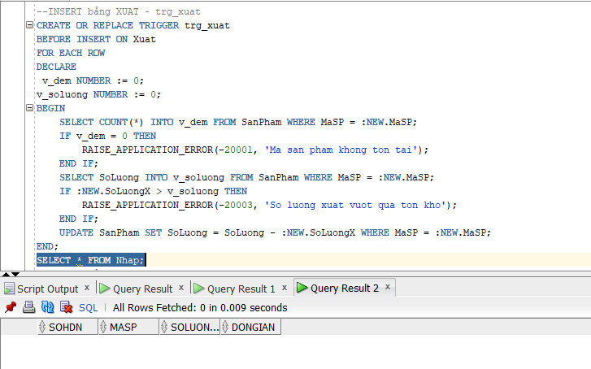
Sau
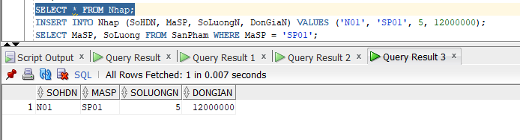
- Trigger INSERT bảng XUAT – trg_xuat
Trước
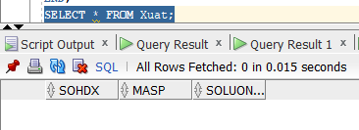
Sau
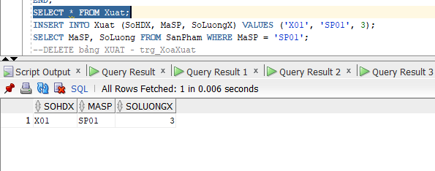
- Test trg_XoaXuat (DELETE Xuất)
Trước
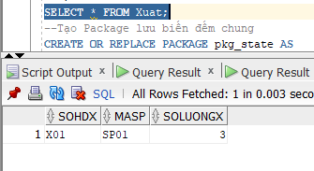
Sau
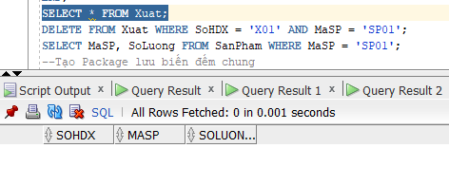
Phiếu học tập 2
- Test trg_CapNhatXuat (UPDATE Xuất)
Trước
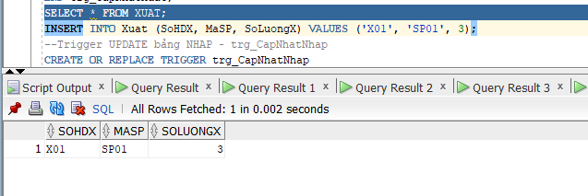
Sau
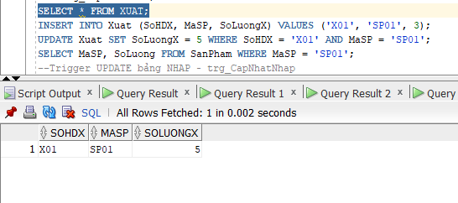
- Test trg_CapNhatNhap (UPDATE Nhập)
Trước
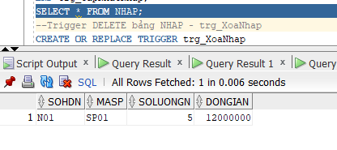
Sau
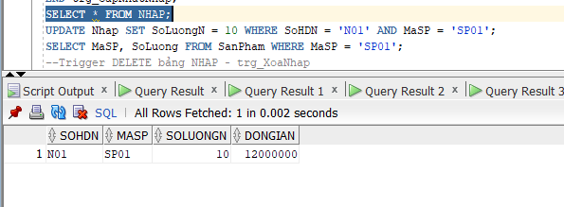
- Trigger DELETE bảng NHAP – trg_XoaNhap
Trước
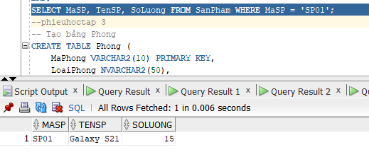
Sau
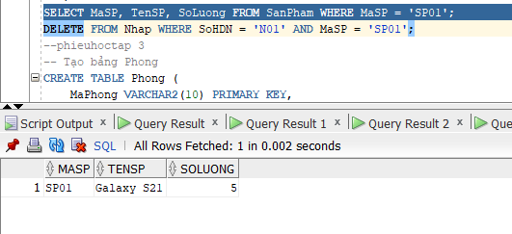

Phiếu học tập 3
A)Trigger INSERT bảng HoaDon — trg_DatPhong
Trước
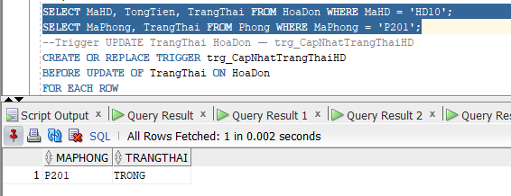
Sau
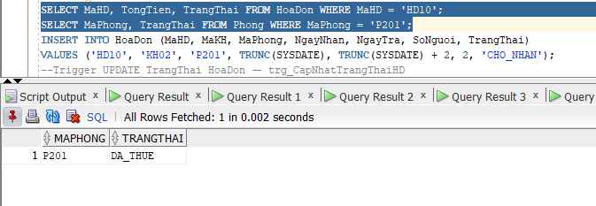
- trg_CapNhatTrangThaiHD (UPDATE TrangThai)
Trước
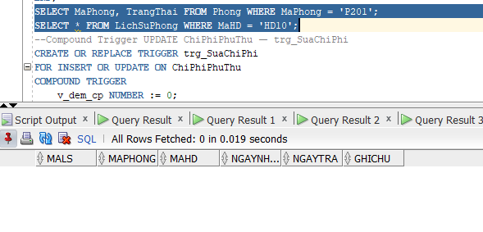
Sau
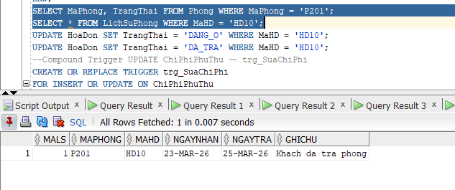
- trg_SuaChiPhi (Compound Trigger)
Trước
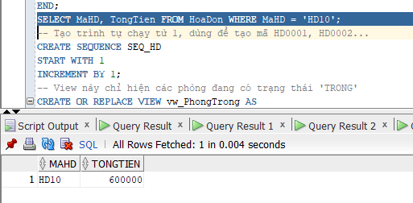
Sau
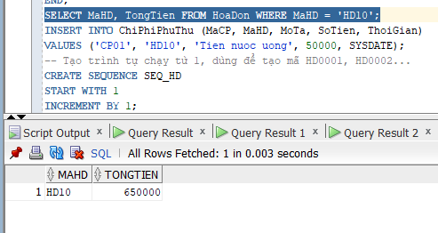
D)INSTEAD OF Trigger trên View — trg_vwPhongTrong_ins
Trước
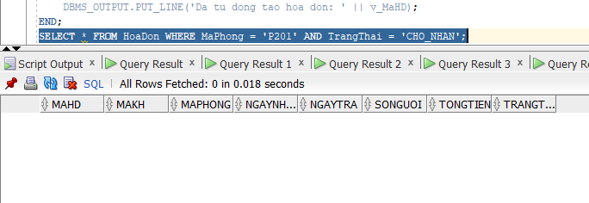
Sau
